Tenda F3--How to Setup Universal Repeater

Step 1: Login the homepage.

- The main router connect to WAN port of F3, PC connect to LAN port of F3.

- Open a browser then type “192.168.0.1” into the Address Bar, press Enter. Then enter the password of this page. Tap “Login”.

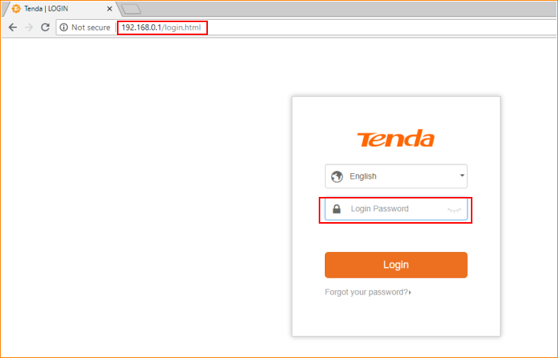

Note: The default password is shown on the bottom of the router. If you have changed it and you also forgot it, see “Forget your password?” below the “Login” button.

- Then the interface will turn into the homepage, tap “Wireless Repeating”, you can see “AP mode” option in this page.

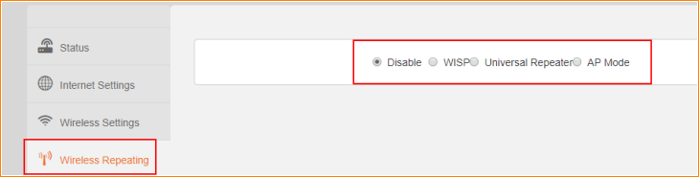

Step 2: Setup AP mode
Note: In AP mode, any port of the router can be used to connect to the uplink router. In this mode, some functions are ineffective, including Interent Settings, Parental Control, Bandwidth Control, Virtual Server, and so on.
- Tap “AP mode”, tap “OK” to save this setting.

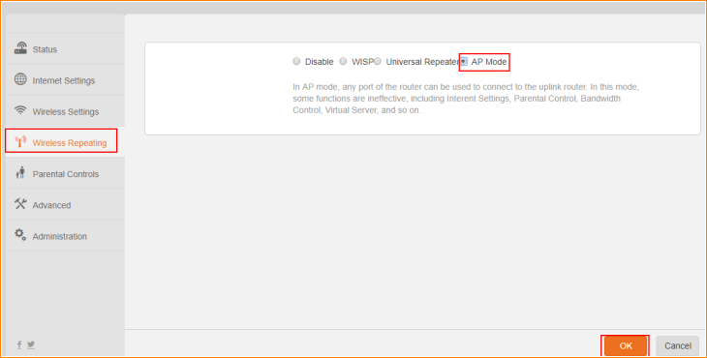

- Tap “OK” on the pop window, then the router will reboot automatically.

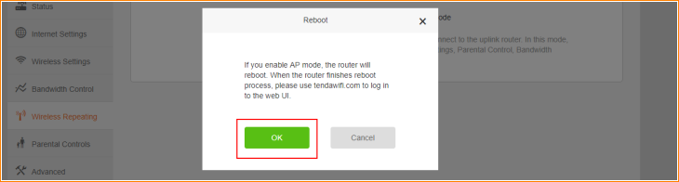

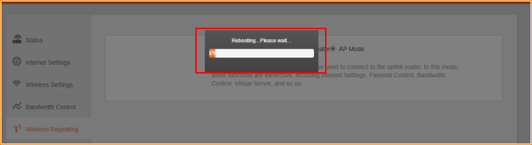

- After rebooting, please use “tendawifi.com” to login to the Web UI. You will see the web UI as shown below. Most of feature option has disappeared, because in AP mode, they are disabled.

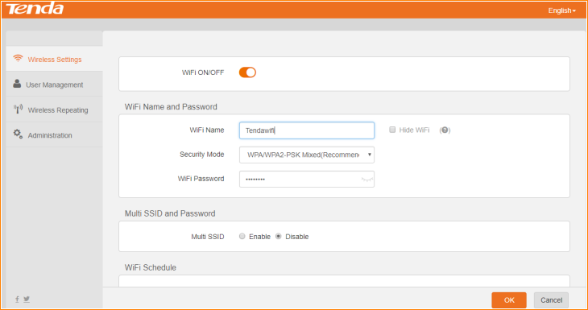

Note: In AP Mode, you can login webpage of router with “tendawifi.com”, if you want to login webpage of F3 with cable, you need to login main router and check IP address of F3.

